|  |
| --- |
| TAG WORLD EXCHANGE  **June 19, 2018**    **ABOUT US** |
|  |
|  |
|  |

TWEX LTD.

A Tag banker company

71-75 SHELTON STREET, COVENT GARDEN, LONDON, WC2H 9JQ, UNITED KINGDOM

contact: +44 203 3185473, +44 745 2284216, +33 76 144 2277

**WHO WE ARE- About Us**

TWEX Limited is a UK Based company that was incorporated to help companies raise funding while helping investors to find attractive targets to invest their funds using our new invention the 'Tokenized Preference Share-Preference Share registered on the Blockchain with inherent non-changeable rights.

TWEX Ltd Succursal Em Portugal was incorporated to issue Our TWEX Tokens.

There are many platforms, many clients, many investors and two main common problems accuracy of information and fraudulent negation of responsibilities. To compound matters you also have the age-old problem of access to funds in case of dire need after making an investment in a private company.

We a TWEX decided to offer investors the possibility to strip their investments, trade any part of it via two smart contracts registered on the Blockchain representing Capital and profit payments, known as **Smart Contract Capital (SCC)** and **Smart Contract Profit (SCP)**.

We also offer to our investors Our TWEX Tokens along with our proprietary new invention the Tokenized Preference Share- the TWEX TPS, these are remitted to investors at the time of our ICO.

Where the TWEX Token is a utility token granting you the rights to use our proprietary software running our site and our Value Determination and Payment probability (VDP) Algorithm used to price any ticker symbol traded on our site for now, the TWEX TPS grants its owner rights to:

* **1% of sales augmentation post and prior funding of each company listed on our Exchange and that benefitted from the funding**
* **30% of all profits realized by our Exchange (trading fees, commissions for fundraising, 0.5 of total sales of all companies listed on our Exchange, Licensing and sale of our proprietary hardware wallet the TWAL, etc.)**

Each investor is also entitled to a pro-rated number of SCC and SCP (Smart contracts Capital and Profit Participation) issued by each company trading on our site that benefitted from the investment.

TWEX Tokens have a limited supply of 500,000,000

TWEX TPS have a limited supply of 500.000.000 at a par value of 0.40 Cents Euro and only 400.000.000 available for sale.

**Please consult our news section regularly for more information about us coming soon**

**TWAL**

One of the main problems of banks in this day and age is ID Theft and people impersonation for malicious activities. We have developed a device that is no bigger than a credit card albeit thicker that will enable user to scan his thumbprint and take a picture of his face in order to match his ID. Once these two operations accomplished, an app on his phone or on his computer will ask to enter his personal self-chosen password - once that is done then and only then will he have access to his banking portal. In essence without his proven ID, no loans, credit card requests, etc. can be processed online - no more ID Theft and horrendous stories about people having to pay for loans that they never contracted.

Similarly our device with an add-on helps to block credit card theft too. Your card in blocked at the back of our device and can be released only if your id is verified by our system. Incidentally we are exposing this solution to top Swiss and French Banks in December. The top Portuguese Bank is also interested to be the first in Portugal to offer this device sold around 45 Euros to their clients along with a 5 € annual service fee.

There are many other applications that are going to follow mid to end of next year.

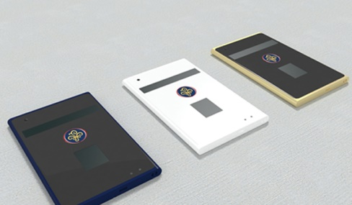

Please feel free to contact us for any more queries you might have.

Please subscribe at: www.twex.eu

**Best regards**

**TWEX Management Team**